* functional requirement:

+ search:

* Title
* Author
* Keywords
* ISBN

+ borrow:

* Check:

+ ID card

+ if valid : check if has any overdue books or unpaid fines

* Reject
* resolve
* Return:

+ Upgrade for borrower:

* Search, order needed items via web, sm phone
* Extend, check availabiltity and reserve books via web, sm phone
* Pay fine online
* Request to ship books by drone

+ book-maintenance

* add:
* Remove:

+ if book damaged when it is returned => last borrower will be assessed a fine

+ if book can be repaired, depend on the cost of the repair => borrower may not be assessed a fine

* Notify:

+ Every Monday, send reminder emails to borrowers who has overdue book:

* If overdue > 2 weeks: borrowers can be assessed additional fines every Monday

1. Context Diagram

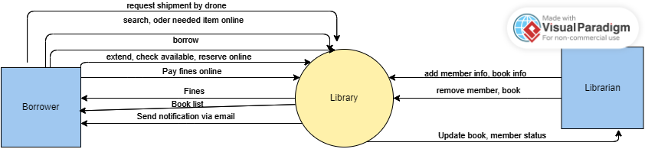

1. Feature tree

LibSys

│

├── Borrower Features

│ ├── Search Books

│ │ ├── Search by Title

│ │ ├── Search by Author

│ │ ├── Search by Keywords

│ │ └── Search by ISBN

│ ├── Order Items

│ ├── Extend Books

│ ├── Check Availability

│ ├── Reserve Books

│ └── Pay Fines Online

│ ├── View Outstanding Fines

│ └── Process Payment

│ └── Request Shipping

│ └── Request Shipping by Drone

│

├── Librarian Features

│ ├── Manage Book Collection

│ │ ├── Add Books

│ │ ├── Remove Books

│ │ └── Update Book Information

│ ├── Process Borrowing Requests

│ ├── Send Reminder Emails

│ └── Manage Borrower Accounts

│ ├── Validate Borrower ID

│ ├── Check Overdue Books

│ └── Assess Fines

│

└── System Features

├── User Authentication

│ ├── Login

│ ├── Change Password

│ └── Forgot Password

├── Notification System

│ ├── Email Notifications

│ └── SMS Notifications

└── Reporting

├── Generate Reports on Borrowing Activity

└── Generate Reports on Overdue Books

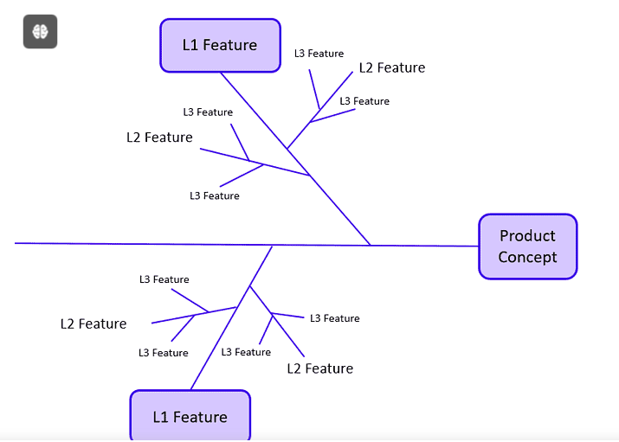

1. Actor, usecases

|  |  |  |
| --- | --- | --- |
| Actor | Usecase | Detail |
| Borrower | Login | - Login  - Change password  - Forget password |
|  | Search | - Look up books and resources by title, image,ISBN  - |
|  | Reserve book | -Reserve books that are currently checked out by others. |
|  | Pay fines | -Settle any fines for overdue books. |
|  | Check available items | -See which books and resources are currently available |

|  |  |  |
| --- | --- | --- |
| Librarian | Resisgter new user | - Enroll new members into the library system. |
|  | Manage records | - Update and maintain records of books, users, and transactions. |
|  | Update database | - Add new books, remove outdated ones, and update book information. |
|  |  |  |

|  |  |  |
| --- | --- | --- |
| LibSys | Send notification | - Get notifications about due dates, overdue books, and fines. |
|  | Generate receipts |  |
|  |  |  |
|  |  |  |

1. Draw usecase diagram

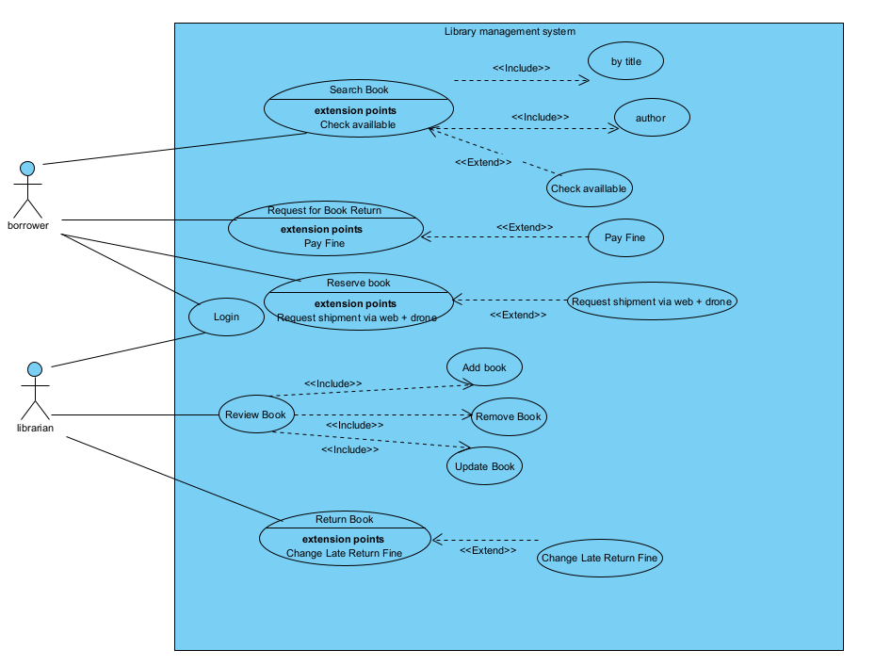

1. 10 scenarios and 10 use stories

|  |  |
| --- | --- |
| User story | Acceptance Criteria |
| 1. As a borrower, I want to search for books so that I can find specific titles or authors. | - Enter keywords in a search bar  - View a list of matching books  - Filter search results by genre or publication date |
| 2. As a borrower, I want to view book details so that I can learn more about a book before borrowing it. | - See the book's author, and publication details  - Check availability status (available, checked out)  - Read reviews or ratings from other borrowers |
| **3. As a borrower, I want to borrow books online so that I can reserve them for pickup.** | - Select a book and click the borrow button  - Receive a confirmation of the borrowing request  - Choose a pickup location and time |
| **4. As a borrower, I want to manage my borrowed books so that I can keep track of due dates.** | - View a list of currently borrowed books  - See due dates and renewal options  - Receive notifications for upcoming due dates |
| **5. As a librarian, I want to add new books to the system so that they are available for borrowing.** | - Fill out a form with book details (title, author, genre, ISBN)  - Upload a cover image for the book  - Save the book entry to the library catalog |
| **6. As a librarian, I want to manage book inventory so that I can keep track of available and checked-out books.** | - View inventory reports showing available and checked-out books  - Update book status (available, checked out, lost)  - Remove books from the catalog that are no longer in circulation |
| **7. As a librarian, I want to assist borrowers with their inquiries so that they have a positive experience.** | - Respond to borrower questions via chat or email  - Provide recommendations based on borrower interests  - Help with account management issues (e.g., password resets) |
| **8. As a librarian, I want to generate reports on borrowing trends so that I can analyze usage patterns.** | - Access reports on the number of books borrowed over time  - View statistics on popular genres or authors  - Export reports for further analysis |
| **9. As a borrower, I want to receive notifications about new arrivals so that I can explore new books.** | - Opt-in for email or SMS notifications  - View a list of new arrivals on the homepage  - Access details about new books directly from notifications |
| **10. As a borrower, I want to use a wishlist feature so that I can save books for future borrowing.** | - Add books to a wishlist from the book details page  - View and manage the wishlist from my account  - Move books from the wishlist to the borrowing request easily |

1. **Draw 3 activity diagrams/swim lane:**

-Two diagrams for borrowing and pay fines by borrower

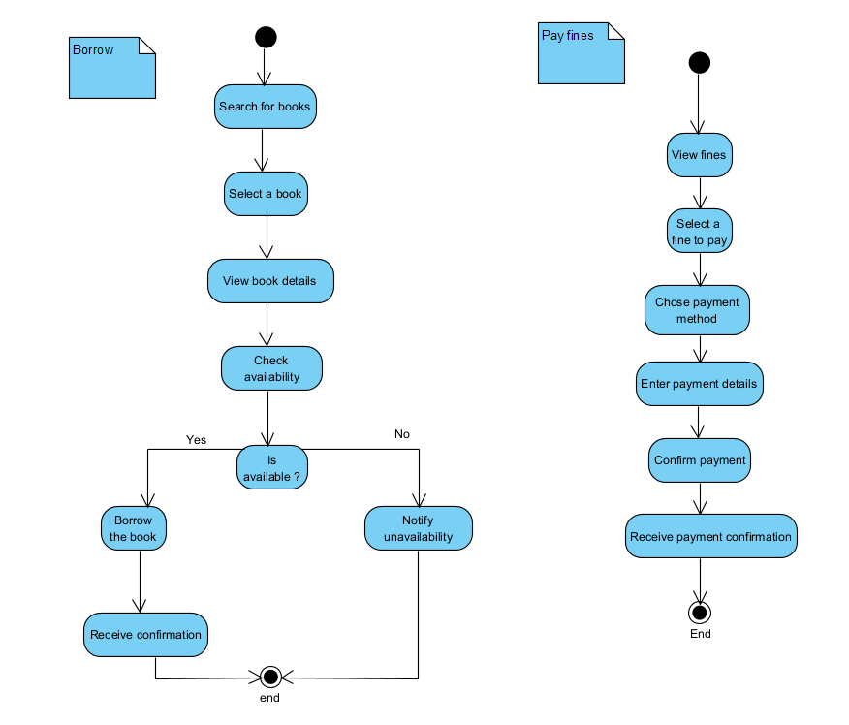

- One for staff processing borrows via web/phone + drone

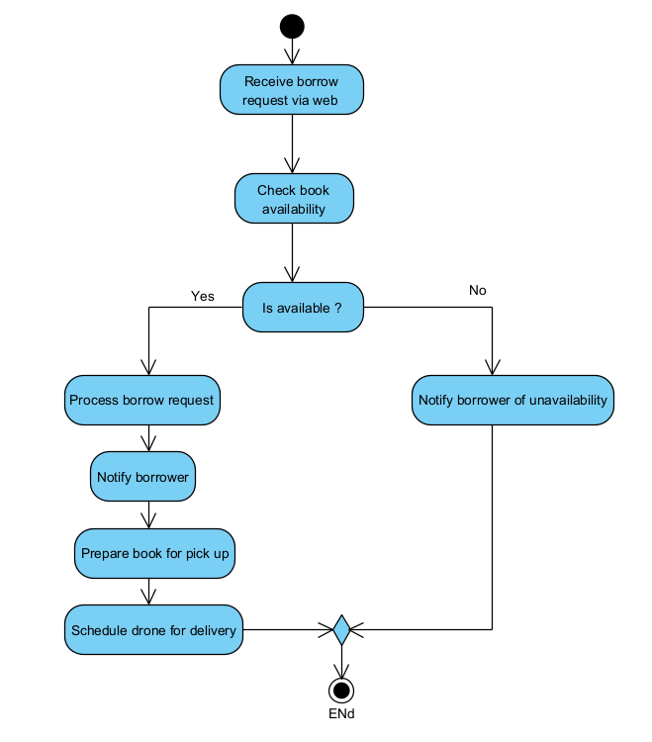

1. Crc cards
2. **Borrower**
3. **Book**
4. **LibraryCollection**
5. **Search**
6. **Reservation**
7. **Loan**
8. **Fine**
9. **Notification**
10. **DroneDelivery**
11. **Librarian**

| **Class** | **Responsibilities** | **Collaborators** |
| --- | --- | --- |
| **Borrower** | - Search books  - Borrow books  - Return books  - Pay fines | Librarian, Book, Fine |
| **Librarian** | - Manage books  - Validate borrower ID  - Process fines | Borrower, Book, Fine |
| **Book** | - Maintain book details  - Update status (available/borrowed)  - Track due dates | Borrower, Librarian |
| **Fine** | - Calculate fines  - Track overdue books  - Process fine payments | Borrower, Librarian |
| **Search** | - Search by title, author, keywords, ISBN | Borrower, Book |
| **Reservation** | - Reserve books  - Notify borrower when available | Borrower, Book |
| **Notification** | - Send reminders  - Notify about overdue books | Borrower, Librarian |
| **Drone** | - Ship books  - Track delivery status | Borrower, Librarian |
| **Payment** | - Process online payments  - Validate transactions | Borrower, Fine |
| **Database** | - Store borrower, book, and transaction details | Borrower, Librarian, Book, Fine |

8. Draw a class diagram (analysis phase): class name + attributes + (methods-option) + relationships + multiplicity

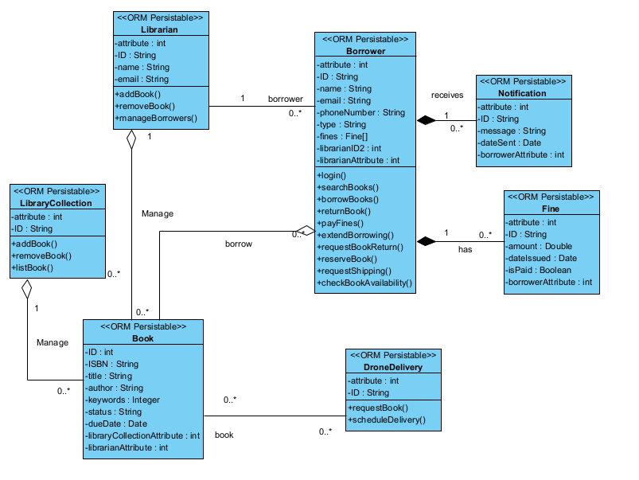

9. Sequence Diagram

10. Generate Data Model

